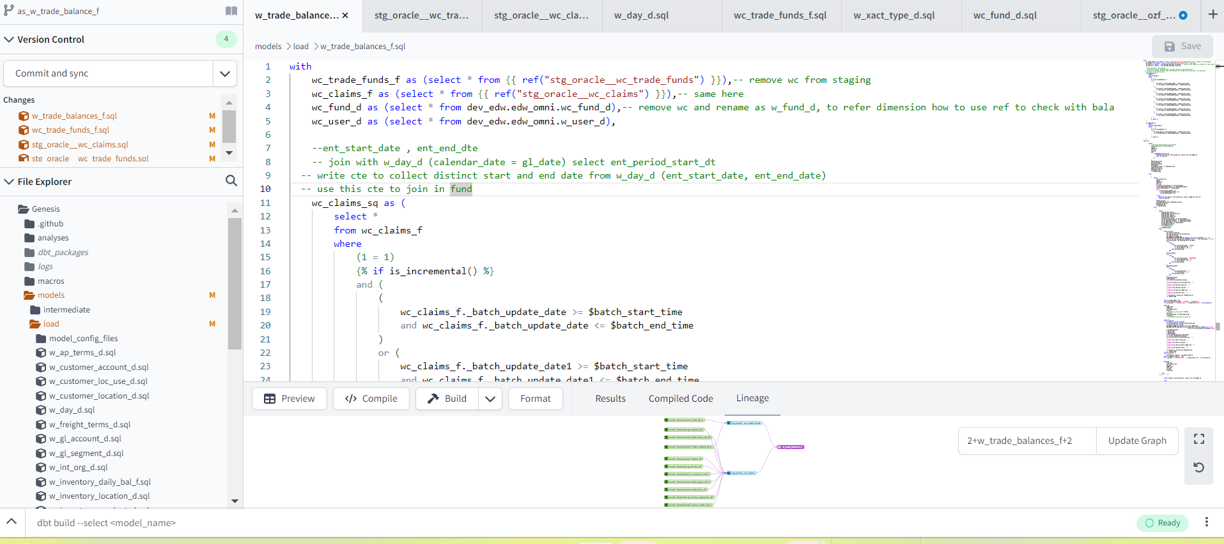

Work for the day:

Confirm validation of sales-demand

Tempo entered

Development plan updated

Bala’s doubt in tempo partially done

Need to work on trade-funds-f staging (2.30pm after bala’s meeting)